Violation of Religious Freedom of Nam Hoài Nhơn Cao Dai Temple
To: Special Rapporteur on freedom of religion or belief
c/o Office of the High Commissioner for Human Rights
United Nations
8-14 avenue de la Paix
CH-1211 Geneva 10, Switzerland
1/- General Information
-Does the incident involve an individual or a group?
A group.
-If it involves a religious or belief group, please state the number of people involved and the denomination of the group
15 members of the independent Cao Dai Church were involved.
-Countr(ies) in which the incident took place: Vietnam
-Nationality(ies) of the victim(s): All are Vietnamese citizens (Kinh ethnicity)
-Does domestic law require (re-) registration of religious associations and if yes, what is the current status of the group in question?
Vietnam requires all religious organizations to register. In Vietnam, the government banned the authentic Cao Dai Church (established in 1926). The state-sponsored Cao Dai denomination (established in 1997) is a tool of the Communist regime for demolishing the independent, authentic Church. The Nam Hoài Nhơn Temple belongs to the independent Cao Dai Church. The government frequently collaborates with its sponsored Church in attempting to seize this temple.
2/- Identity of the Persons Concerned
Please see Addendum 1.
3/- Information regarding the alleged violation
-Date and time (approximate, if exact date is not known):
Afternoon of 7/27, 8 a.m. on 7/23, and 7/25/2017
-Place (location and country/countries):
Nam Hoài Nhơn Temple at: Hoài Tân Commune, Hoài Nhơn District, Bình Định Province
Please provide a detailed description of the circumstances of the incident in which the alleged violation occurred and the nature of the government action:
7/22/2017 (afternoon): 8 employees of the commune government and district government came to the temple to give a few soda bottles to Mrs. Phan Hương Đành, the Elder of the congregation (their agenda was to assess the situation in preparation for the government’s taking over the temple).
7/23/2017 8 a.m.: on this first day of the lunar month, as the temple staff was preparing to conduct customary rites, government representatives and members of the government-sponsored Church entered the temple. The group included:
Võ xuân Phong, deputy chairperson of Hoài Tân Commune,
Ngô Tư, chairperson of the commune’s Fatherland Front, and
A number of plainclothes policemen from the commune police force, and,
Nguyễn Hợp (religious name: Thái Hợp Thanh), lead representative of Bình Định Province’s government-sponsored Church,
Hồ tấn Thu (religious name: Thượng thu Thanh), deputy lead representative of Bình Định Province’s government-sponsored Church, and
Võ văn Đồng, government-sponsored Church member.
They approached the altar and began to read aloud their order to expel Mrs. Phan Hương Đành [religious name] (legal name: Phan Thị Đành), the Elder of Nam Hoài Nhơn Temple’s congregation. The initial government group included 6 additional employees of the Hoài Nhơn District government, but these officials left upon seeing the strong resistance by the Temple’s adherents.
After trying for 3 hours to pressure the Nam Hoài Nhơn congregation, the government and government-sponsored groups withdrew.
7/25/2017: 3 government-sponsored Church members,
Messrs. Tín, Hải and Thêu,
along with a number of plainclothes policemen entered the temple. They claimed that they were looking for 2 electric drills that they had left in the temple’s religious objects storage cabinet (an authentic Church’s adherent, Mr. Lương, is in charge of the cabinet). The made-up story was the government’s pretext to try and seize the cabinet although the authentic Church owns it. There is no reason why the 2 drills would have been stored in the cabinet: this was Mr. Lương and the other authentic adherents’ rebuttal. The government’s party left.
-Which indications exist that the victim(s) has been targeted because of his/her religion or belief?
In various districts in Vietnam, government officials such as police officers, members of the Religious Affairs Committee, and members of the state-sponsored Cao Dai denomination have been attempting to pressure the followers of the independent Cao Dai Church (founded in 1926) to join the state-sponsored denomination that the government established in 1997.
Are the perpetrator(s) known to the victim? Yes
Are State agents or non-State-actors believed to be responsible for the alleged violation?
The perpetrators are government employees and members of the government's Cao Dai denomination.
-If the perpetrators are believed to be State agents, please specify (police, military, agents of security services, unit to which they belong, rank and functions, etc.), and indicate why they are believed to be responsible; be as precise as possible.
It is evident that the perpetrators are state agents (see their names and affiliations in a previous section)
If identification as State agents is not possible, do you believe that government authorities or persons linked to them, are responsible for the incident? Why?
The victims could identify the perpetrators as state agents, i.e., Vietnamese government employees and members of the state-controlled Cao Dai denomination.
  - If there were witnesses for this event, please provide their names, relationship with victims, and contact information, e.g., email address, telephone numbers. In case they choose to keep their identities secret, state if they are family members, passers-by, etc. Please supply any available evidence.
The victims are their own witnesses.
4/- Steps taken by the victim, his/her family, or anyone else on his/her behalf?
-Please indicate if complaints have been filed, when, by whom, and before which State authorities or competent bodies (i.e., police, prosecutor, court, etc.). The temple’s representatives will shortly send a complaint to the local government and government-controlled Church.
-Were there any other steps taken? None.
- Steps taken by the authorities: None.
-Indicate whether or not, to your knowledge, there have been investigations by the State authorities; if so, what kind of investigations? Please indicate progress and status of these investigations as well as which other measures have been taken.
The government does not and will not investigate because, as in numerous other cases, it is the mastermind and coordinator of the violations.
-In case of complaints by the victim or his family, how have those authorities or other competent bodies dealt with them? What has been the outcome of those proceedings?
None.
5/- Identity of the person or institution submitting this form:
-Family name: _____ -First name: _________ (edited out for security reason)
-Contact number: Skype name: _________ -Status: member of Association for Religion and Belief (NGO)
If the victims did not prepare this report, do you act with knowledge and on behalf of the victim(s)? Yes, the victims knew and collaborated on this reporting activity.
Please state whether you want your identity to be kept confidential: Yes
Report submitted on: July 29, 2017
Signature: ____________
Addendum 1. List of victims
They are members of the authentic Cao Dai Church and authorized ___________ to represent them.
1/ Family name: Phan Given name: Thị Đành Address: Hoài Tân Commune, Hoài Nhơn District, Bình Định Province. Birth date: 1934 Gender: Female
2/- Ngô Văn Đông, 1963, congregation’s secretary. Đệ Đức 3 Village, Hoài Tân Commune, Hoài Nhơn.
3/- Nguyễn Thị Nga, 1947, Đệ Đức 1 Village, Hoài Tân Commune, Hoài Nhơn District.
4/- Nguyễn Văn Xuân,1974, Đệ Đức 3 Village, Hoài Tân Commune, Hoài Nhơn District.
5/- Nguyễn Cường. Đệ Đức 1 Village, Hoài Tân Commune, Hoài Nhơn District.
6/- Trần Dũng. Thiết Đính Village, Town of Bồng Sơn, Hoài Nhơn District.
7/- Nguyễn Văn Đức. Hoài Đức Commune, Hoài Nhơn District.
8/- Phan Văn Bường. Hoài Hương Commune, Hoài Nhơn District.
9/- Huỳnh Kim Lương. Hoài Đức Commune, Hoài Nhơn District District.
10/- Võ hòa. An Vinh Village, Hoài Tân Commune, Hoài Nhơn District.
11/- Nguyễn Hữu Khanh. 1964, Mỹ Phú Đông Village, Mỹ Lợi Commune, Dục Mỹ District, Bình Định.
12/- Nguyễn Thị Hạnh. Hoài Đức Commune, Hoài Nhơn District.
13/- Trần Thị Mua. Thiết Định Village, Town of Bồng Sơn, Hoài Nhơn District.
14/- Nguyễn Cũng. Song Khánh Village, Hoài Xuân Commune, Hoài Nhơn District.
15/- Nguyễn Thị Nương. Địa chỉ: An Dưỡng Village, Hoài Tân Commune, Hoài Nhơn District.

Addendum 2. Photos
These photographs show members of the government’s team and the authentic Cao Dai adherents of the temple debating the government’s order to seize the independent temple.
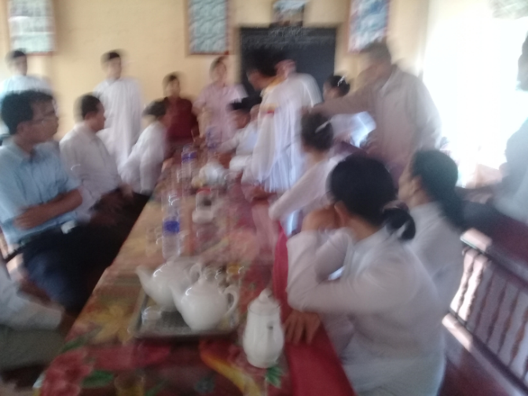
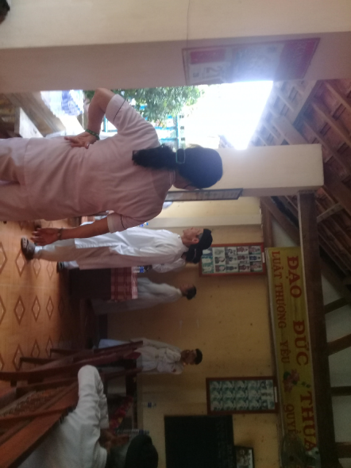
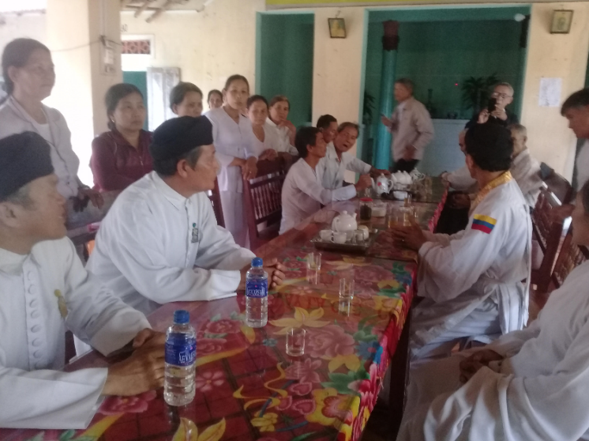
Addendum 3. Sound clips of arguments between the temple’s authentic Cao Dai adherents and the intruders over the government’s order to seize the independent temple.

