<https://www.scmp.com/article/23576/action-group-arms-over-viet-camp-cutbacks>

<https://asamnews.com/2020/03/17/new-report-southeast-asian-americans-targeted-for-deportations/>

At forum on US – Vietnam Relations organized by Fund for Reconciliation & Development, April 12, 2000, Plaintiff was introduced as “Dr. Khoa”. Other speakers included Stanley Roth, Assistant Secretary of State for East Asian and Pacific Affairs.

See (at 1:45:00): <https://www.c-span.org/video/?156556-1/american-vietnamese-relations>

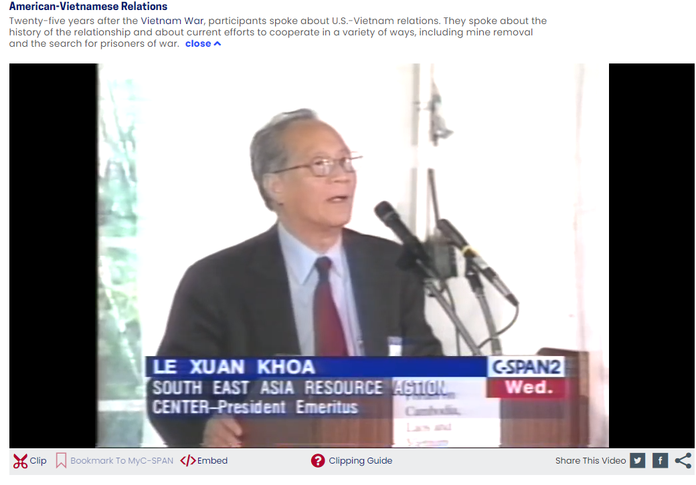

<https://courses.ucsd.edu/syllabi/SP06/566054.pdf>

Course at UC Irvine

